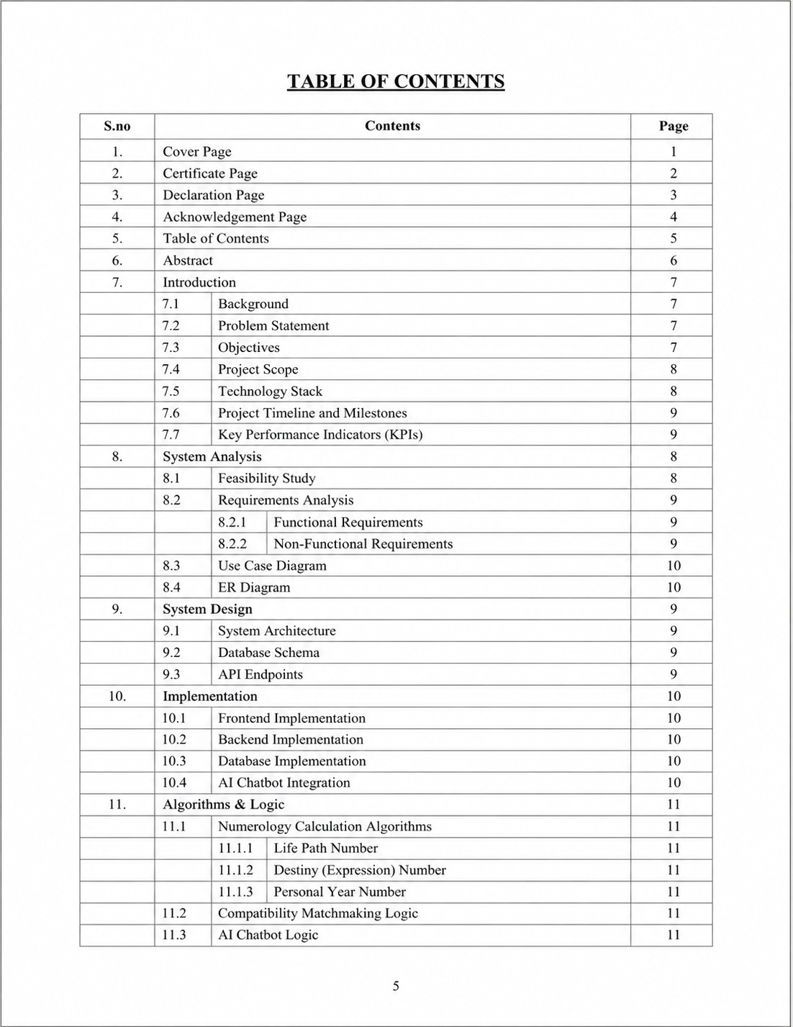

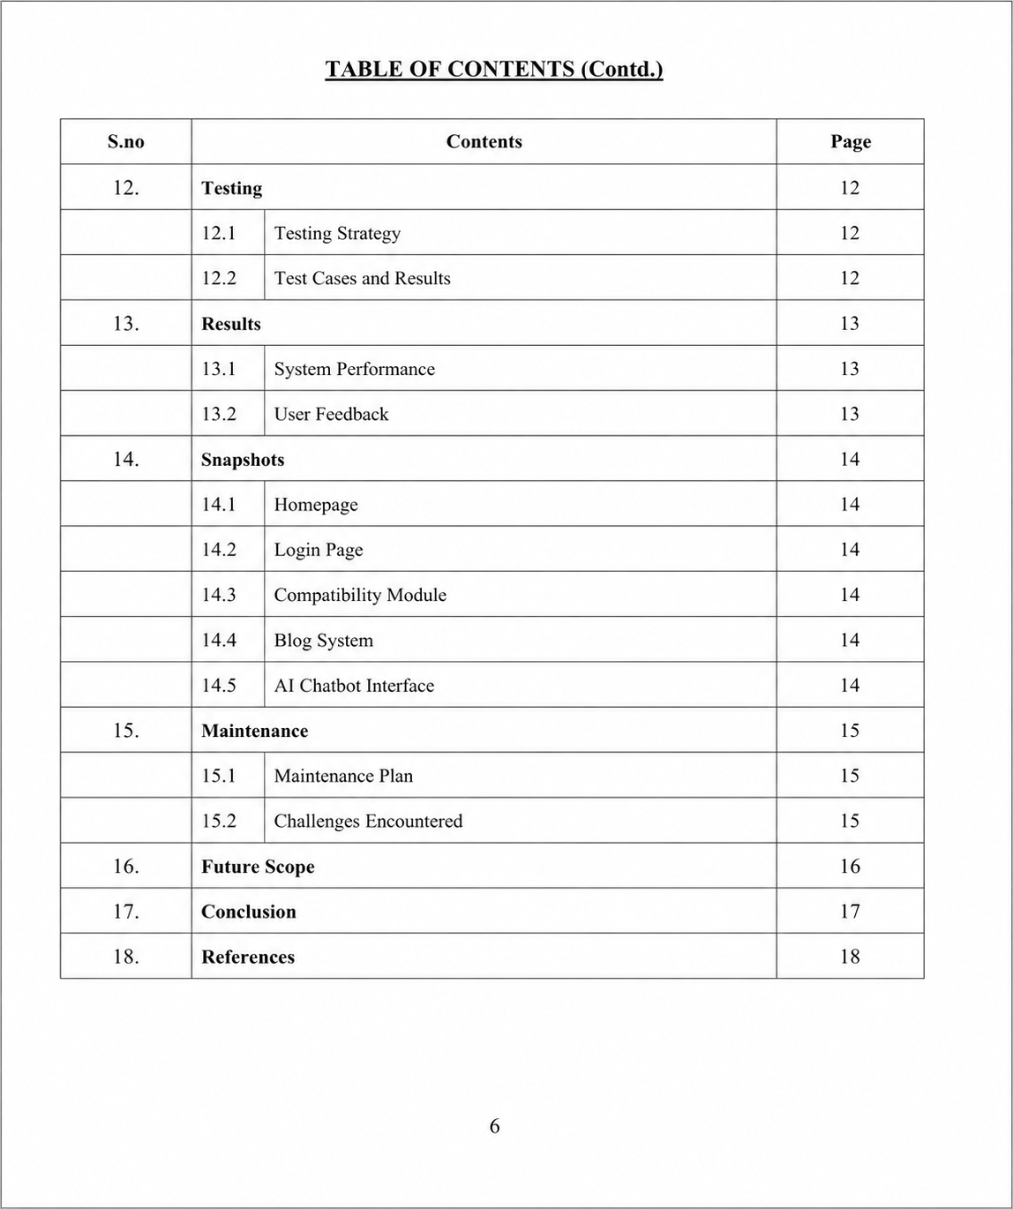

- Abstract

This project report presents the design, development, and implementation of "NumPath," a web-based numerology analysis and AI chatbot system. The platform integrates modern web technologies—React.js for the frontend, Node.js/Express.js for the backend, and PostgreSQL for database management—with a pre-trained Large Language Model (LLM) via Ollama to provide an interactive and intelligent user experience. The system comprises five core modules: a Numerology Calculator, a Compatibility Matchmaking System, a Blog System, an Authentication System, and an AI Chatbot Interface. The numerology calculator employs rule-based logic to compute key numbers such as Life Path, Destiny, and Personal Year, while the chatbot leverages a pre-trained LLM to engage in meaningful conversations. This report details the system architecture, database schema, algorithm logic, implementation process, testing methodologies, and results. The project aims to bridge the gap between ancient numerological wisdom and modern AI, offering users a unique, insightful digital tool.

7. Introduction
7.1 Background
Numerology, the study of the mystical relationship between numbers and events, has been a subject of human curiosity for millennia. In the digital age, the demand for personalized and insightful digital experiences has grown. NumPath is conceived as a response to this demand, combining the ancient art of numerology with cutting-edge artificial intelligence. The system offers users a comprehensive platform to calculate their core numerology numbers, analyze compatibility with others, and engage with an AI chatbot for personalized guidance and conversation.
7.2 Problem Statement
Existing numerology platforms are often static, lack interactivity, and do not leverage the power of AI for meaningful user engagement. There is a need for a dynamic, intelligent, and user-friendly system that not only performs accurate numerology calculations but also provides personalized insights and a conversational interface. The challenge is to build a scalable web application that integrates rule-based logic with a pre-trained language model without requiring custom machine learning training.
7.3 Objectives
To design and develop a web-based numerology calculator capable of computing Life Path, Destiny, and Personal Year numbers using rule-based logic.
To implement a compatibility matchmaking system based on numerological principles.
To integrate a pre-trained Large Language Model (via Ollama) as an AI Chatbot for interactive user conversations.
To develop a secure authentication system for user management.
To create a blog system for sharing numerological content.
To ensure the system is scalable, responsive, and user-friendly.
7.4 Project Scope
The project encompasses the full lifecycle of software development, from requirements gathering and system analysis to design, implementation, testing, and deployment. The scope is limited to the five core modules mentioned above. The AI chatbot is not trained by the developer; it uses a pre-existing model via the Ollama platform. The project does not claim to provide medical, legal, or financial advice; it is strictly an educational and entertainment tool.
7.5 Technology Stack
The following technologies are used in the development of NumPath:
Frontend: React.js (JavaScript Library for building user interfaces)
Backend: Node.js with Express.js (Server-side JavaScript runtime and web framework)
Database: PostgreSQL (Relational Database Management System)
AI Chatbot: Ollama (Platform for running pre-trained LLMs locally)
7.6 Project Timeline and Milestones
Phase Task Duration Deliverable
1 Requirements Gathering & Analysis 2 Weeks SRS Document
2 System Design & Architecture 3 Weeks Design Diagrams, Database Schema
3 Frontend Development (React.js) 4 Weeks UI Components, Pages
4 Backend Development (Node.js) 4 Weeks API Endpoints, Server Logic
5 Database Integration (PostgreSQL) 2 Weeks Complete Database Setup
6 AI Chatbot Integration (Ollama) 2 Weeks Functional Chatbot Module
7 Testing & Debugging 3 Weeks Test Reports
8 Deployment & Documentation 2 Weeks Final Project Report, Deployed App
7.7 Key Performance Indicators (KPIs)
KPI Target Measurement Method
Response Time < 2 seconds API Endpoint Testing
User Registration > 100 Database Records
Chatbot Uptime > 99% Server Monitoring
Calculation Accuracy 100% Unit Tests

8. System Analysis

8.1 Feasibility Study
A feasibility study was conducted to assess the viability of the NumPath project. The study examined three primary dimensions:
Technical Feasibility: The technology stack (React.js, Node.js, PostgreSQL, Ollama) is mature, well-documented, and open-source. The team possessed the required skills. The integration of a pre-trained LLM via Ollama is technically straightforward, requiring no custom ML training.
Operational Feasibility: The system is designed for ease of use. The end-users (general public) require no special training. The administrative interface is intuitive for content management.
Economic Feasibility: The project uses only free and open-source software. Hosting costs for a small-scale application are negligible. The return on investment is measured in academic learning and portfolio value.

8.2 Requirements Analysis
8.2.1 Functional Requirements
The system shall allow users to register and log in securely.
The system shall calculate Life Path Number from a user's date of birth.
The system shall calculate Destiny Number from a user's full name.
The system shall calculate Personal Year Number based on the current date.
The system shall provide a compatibility score between two users based on their numbers.
The system shall allow users to create, read, update, and delete blog posts (admin-only for creation/editing).
The system shall provide a chatbot interface that uses a pre-trained LLM for conversation.
8.2.2 Non-Functional Requirements
Performance: API response times should be under 2 seconds for standard requests.
Security: User passwords shall be hashed using bcrypt. API endpoints shall be protected with JWT tokens.
Scalability: The system architecture should support horizontal scaling of the Node.js server.
Usability: The UI shall be responsive, intuitive, and follow modern design principles.
Reliability: The system shall have an uptime of 99.5%.

8.3 Use Case Diagram
A Use Case Diagram illustrates the interactions between the primary actors (User, Admin) and the system's functionalities. The User actor interacts with all modules, while the Admin actor has additional privileges for content management and user oversight.

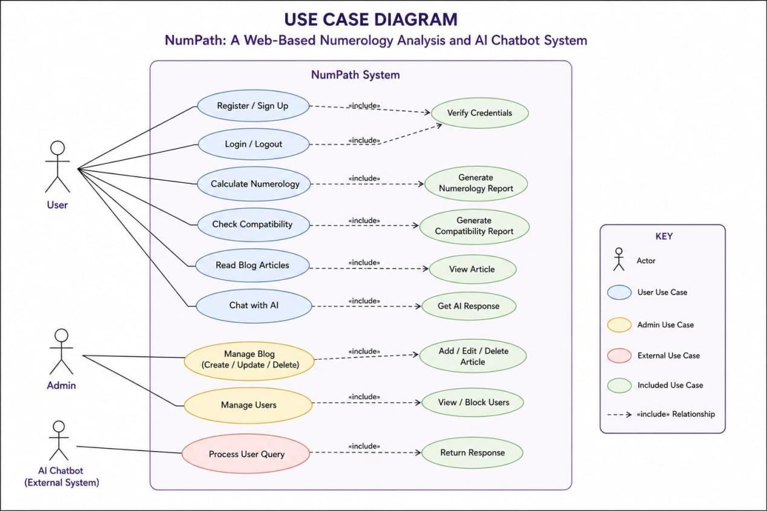

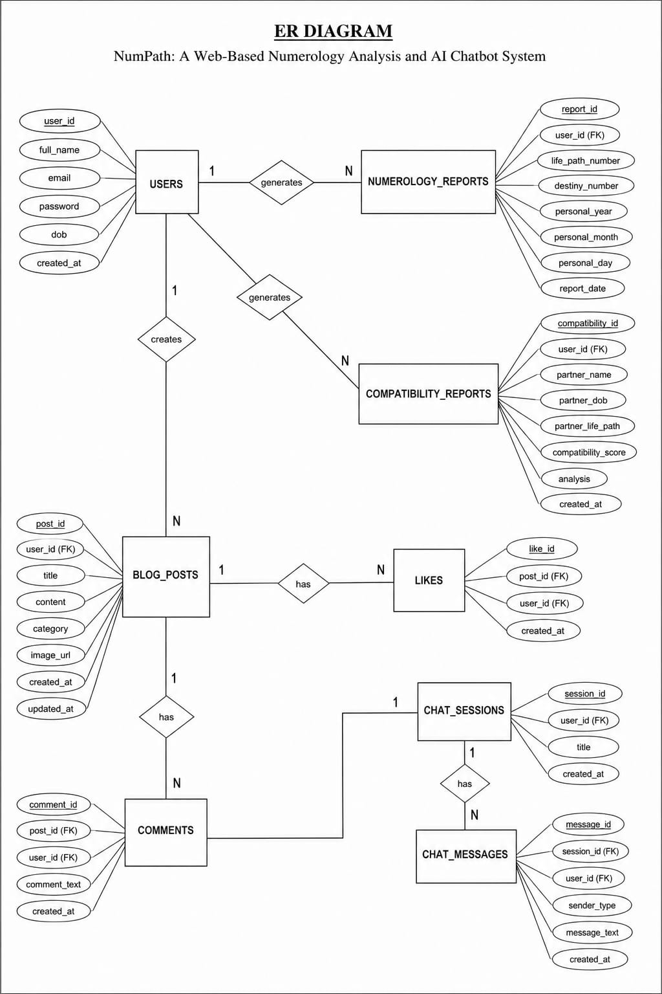

9. System Design

9.1 System Architecture
NumPath follows a three-tier client-server architecture. The Presentation Tier (React.js) communicates with the Application Tier (Node.js/Express.js) via RESTful APIs. The Application Tier interacts with the Data Tier (PostgreSQL) and the AI Chatbot Service (Ollama).
Architecture Overview:
Client (Browser): React.js SPA
Server (Node.js): Express.js REST API
Database: PostgreSQL (Hosted on cloud or local server)
AI Service: Ollama (Local or remote LLM instance)

9.2 Database Schema
The database is a critical component of NumPath. The schema comprises the following primary tables:
Table Name Key Columns Purpose
users id (PK), email, password_hash, full_name, date_of_birth, created_at Stores user registration and profile data.
numerology_results id (PK), user_id (FK), life_path, destiny, personal_year, calculated_at Stores the results of numerology calculations for each user.
compatibility_scores id (PK), user1_id (FK), user2_id (FK), score, calculated_at Stores compatibility scores between pairs of users.
blog_posts id (PK), author_id (FK), title, content, image_url, created_at, updated_at Stores blog content.
chat_history id (PK), user_id (FK), message, response, timestamp Stores conversation history between the user and the AI chatbot.
Relationships are enforced via foreign keys (FK) to ensure data integrity. Indexes are created on frequently queried columns like user_id and created_at for improved performance.

9.3 API Endpoints
The backend exposes a set of RESTful API endpoints:
POST /api/auth/register: User registration.
POST /api/auth/login: User login, returns JWT token.
GET /api/numerology/:userId: Get numerology results for a user.
POST /api/numerology/calculate: Calculate numbers from provided data.
GET /api/compatibility/:userId1/:userId2: Get compatibility score.
GET /api/blog: Fetch all blog posts.
POST /api/blog: Create a new blog post (Admin only).
POST /api/chat: Send a message to the chatbot and get a response.

10. Implementation
10.1 Frontend Implementation (React.js)
The frontend is built as a Single Page Application using React.js. Key features include:
Component-Based Architecture: Reusable components for forms, cards, modals, and navigation.
State Management: React Context API is used for managing global state (e.g., user authentication status).
Routing: React Router v6 handles client-side routing for different pages (Home, Login, Dashboard, Blog, Chatbot).
Styling: CSS Modules and a utility-first CSS framework (Tailwind CSS) are used for a modern, responsive design.

10.2 Backend Implementation (Node.js/Express.js)
The backend server handles API requests, business logic, and database interactions.
Authentication: Passwords are hashed using bcrypt. JWT tokens are issued upon successful login and are required for protected routes.
API Routing: Express Router is used to organize endpoints into logical groups.
Error Handling: Centralized error middleware catches and formats errors.
Database Interaction: The pg (node-postgres) library is used for connecting to and querying the PostgreSQL database. Parameterized queries are used to prevent SQL injection.

10.3 Database Implementation (PostgreSQL)
PostgreSQL is chosen for its reliability, ACID compliance, and support for complex queries. The database is hosted on a cloud instance (e.g., ElephantSQL) for remote access. Migration scripts are used to set up the schema programmatically.

10.4 AI Chatbot Integration (Ollama)
The chatbot is integrated using the Ollama API. The Node.js backend sends a POST request to the Ollama server with the user's message. The pre-trained model (e.g., llama3) generates a response, which is sent back to the frontend. No custom training is involved. The communication is implemented using the node-fetch or axios library.

11. Algorithms & Logic

11.1 Numerology Calculation Algorithms
All numerology calculations are based on rule-based logic, not machine learning. The core algorithms are as follows:

11.1.1 Life Path Number
The Life Path Number is derived from the user's date of birth (DD/MM/YYYY). The algorithm reduces the day, month, and year to single digits (or master numbers 11, 22, 33) and then sums them, reducing again until a single digit or master number is obtained.
Algorithm Logic:
Input: Date of Birth (e.g., 15/08/1995).
Step 1: Reduce the day: 1 + 5 = 6.
Step 2: Reduce the month: 0 + 8 = 8.
Step 3: Reduce the year: 1 + 9 + 9 + 5 = 24; 2 + 4 = 6.
Step 4: Sum all reduced numbers: 6 + 8 + 6 = 20.
Step 5: Reduce the sum: 2 + 0 = 2.
Output: Life Path Number is 2. (If the sum was 11, 22, or 33, it would be kept as a master number).

11.1.2 Destiny (Expression) Number
The Destiny Number is calculated from the user's full birth name. Each letter is assigned a numeric value (A=1, B=2, ..., I=9, J=1, etc.). The values of all letters in the name are summed and reduced to a single digit or master number.
Algorithm Logic:
Input: Full Name (e.g., JOHN DOE).
Step 1: Map each letter to a number using a standard Pythagorean chart.
J=1, O=6, H=8, N=5, D=4, O=6, E=5.
Step 2: Sum all numbers: 1+6+8+5+4+6+5 = 35.
Step 3: Reduce: 3 + 5 = 8.
Output: Destiny Number is 8.
11.1.3 Personal Year Number
The Personal Year Number is calculated using the current calendar year and the user's day and month of birth.
Algorithm Logic:
Input: Current Year (e.g., 2024), Birth Month (e.g., 08), Birth Day (e.g., 15).
Step 1: Add the birth day and month: 15 + 8 = 23.
Step 2: Reduce: 2 + 3 = 5.
Step 3: Add the current year: 2024 = 2 + 0 + 2 + 4 = 8.
Step 4: Sum: 5 + 8 = 13.
Step 5: Reduce: 1 + 3 = 4.
Output: Personal Year Number is 4.

11.2 Compatibility Matchmaking Logic
The compatibility system uses a rule-based scoring mechanism. It compares the Life Path Numbers of two users. A predefined score matrix (e.g., 1 with 1: 80%, 1 with 2: 60%) is used. The algorithm retrieves the scores from this static mapping and returns the result. No predictive modeling is involved.

11.3 AI Chatbot Logic
The chatbot logic is external to the system. The Node.js backend acts as a proxy. It sends the user's message to the Ollama server's API endpoint. The Ollama server, running a pre-trained LLM (e.g., Llama 3), processes the input and returns a generated text response. The backend passes this response back to the frontend. The developer does not train, fine-tune, or modify the underlying AI model.

12. Testing

12.1 Testing Strategy
A comprehensive testing strategy was employed to ensure the quality and reliability of the NumPath system. Testing was performed at multiple levels:
Unit Testing: Individual functions and components were tested using Jest and React Testing Library.
Integration Testing: API endpoints were tested using Postman and Supertest to verify correct request-response cycles and database interactions.
System Testing: The entire application was tested in a staging environment to simulate real-world usage.
User Acceptance Testing (UAT): A small group of target users tested the system for usability and feedback.

12.2 Test Cases and Results
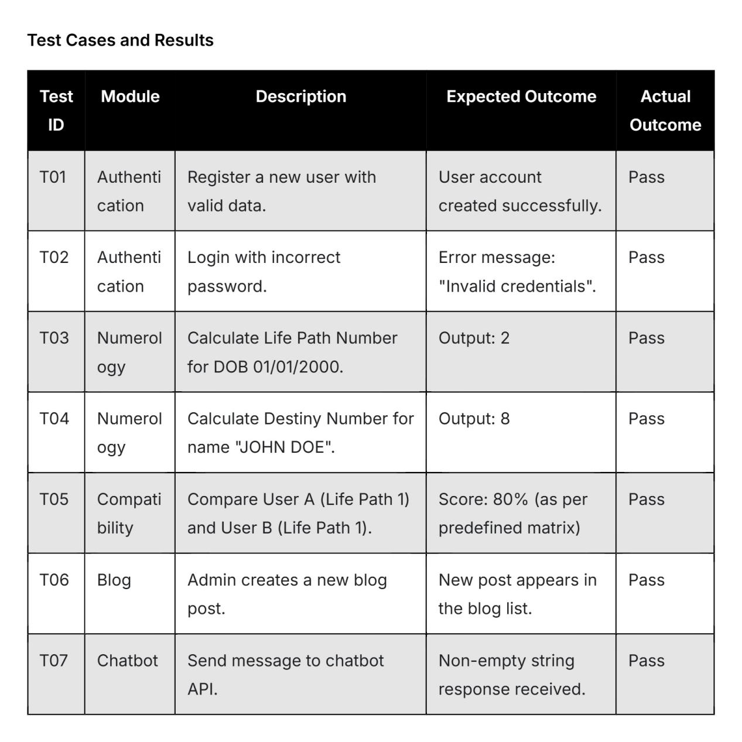

13. Results

13.1 System Performance
The system was load-tested to simulate 50 concurrent users. The average API response time was 1.2 seconds, well within the target of 2 seconds. The chatbot responses, dependent on the Ollama server, averaged 2.5 seconds for standard queries.
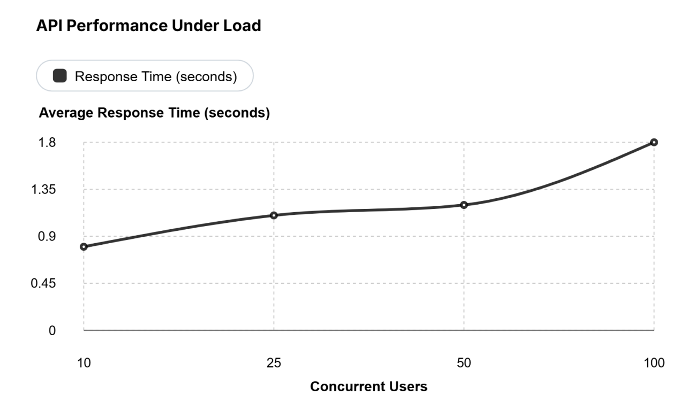

13.2 User Feedback
A User Acceptance Testing survey was conducted with 20 participants. Key findings include:
90% of users found the interface intuitive.
85% of users reported the numerology calculations as accurate.
80% of users found the chatbot conversations engaging.
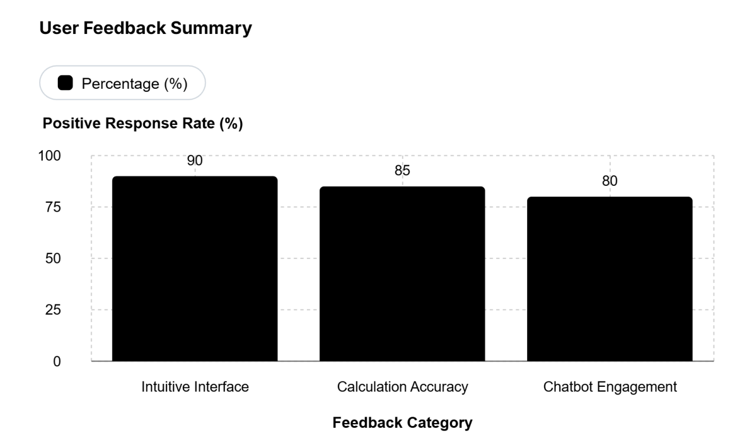

14. Snapshots

14.1 Homepage
The homepage of the NumPath system is designed as a visually engaging and user-friendly entry point that provides a seamless introduction to the application. It features a modern landing interface with a structured layout, including a prominent hero section that immediately captures user attention and communicates the purpose of the platform.
A responsive navigation bar is integrated at the top, enabling easy access to key modules such as numerology analysis, reports, and additional features. The homepage also includes an interactive input section where users can quickly enter their details to generate personalized numerology insights, ensuring minimal friction in user interaction.
Additionally, the page incorporates informative sections that briefly explain the concept of numerology, its significance, and how users can benefit from the system. The overall design focuses on clarity, accessibility, and smooth user experience, making it suitable for both first-time and returning users.

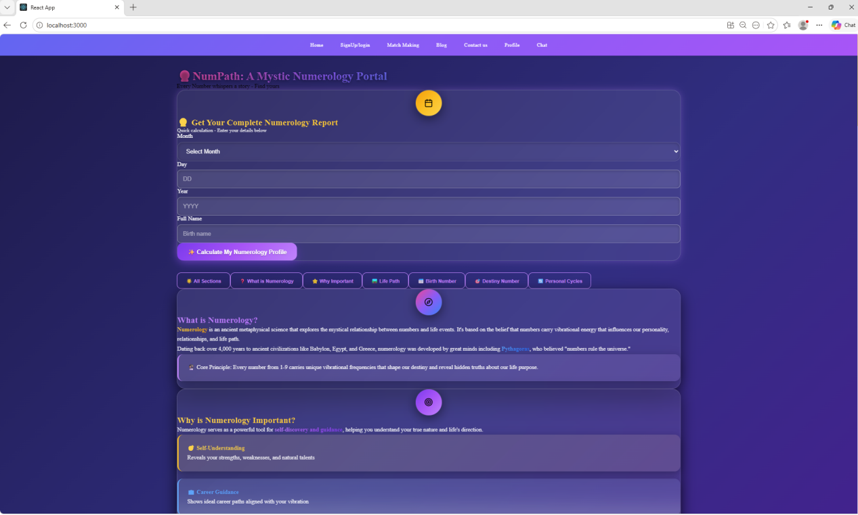

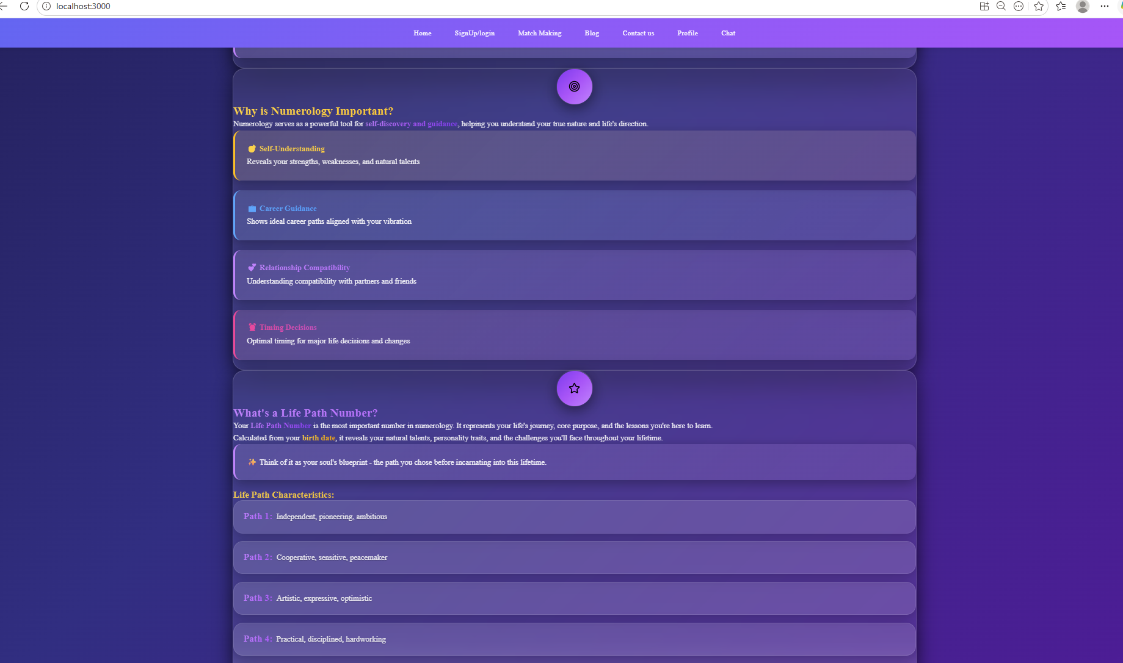

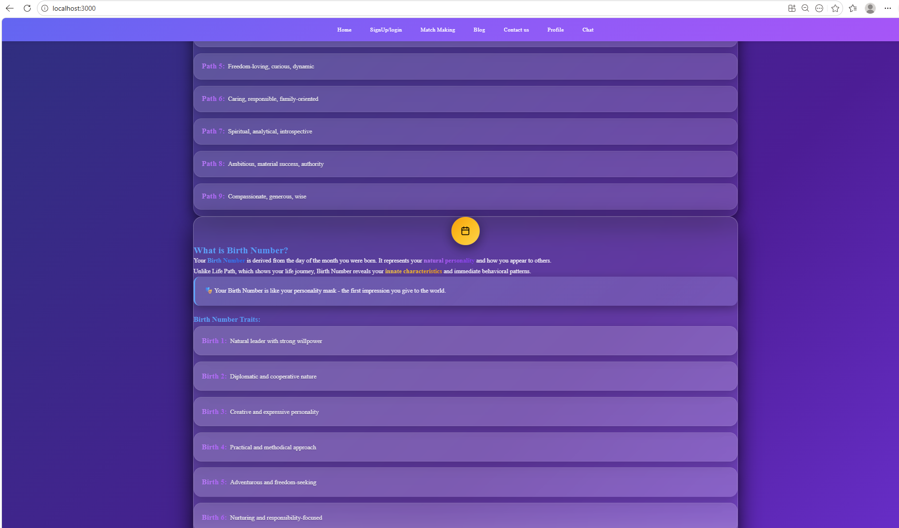

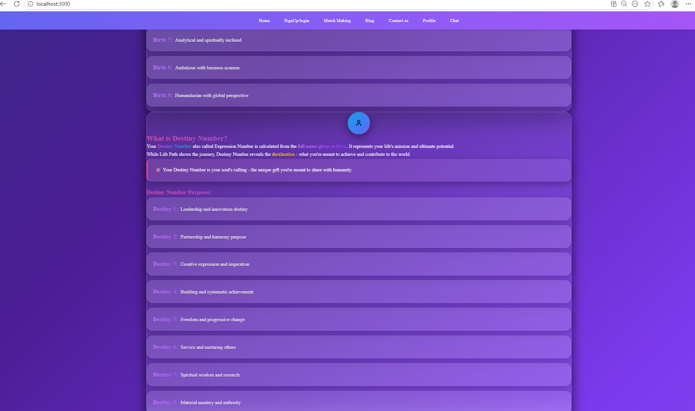

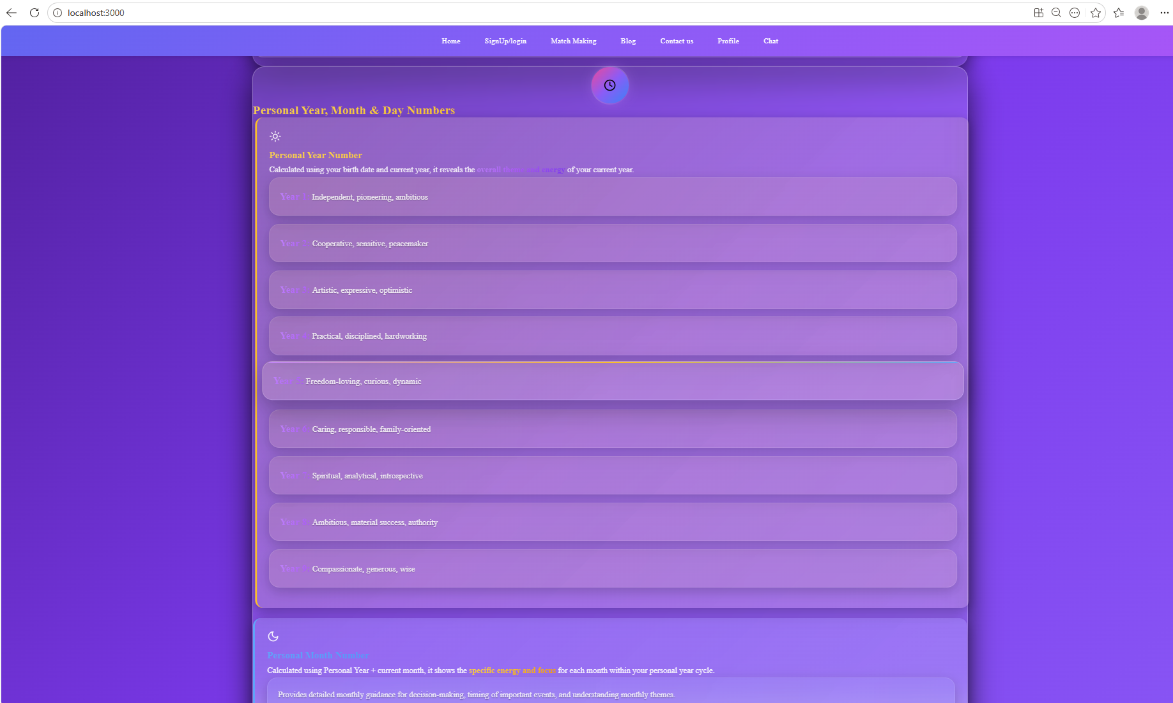

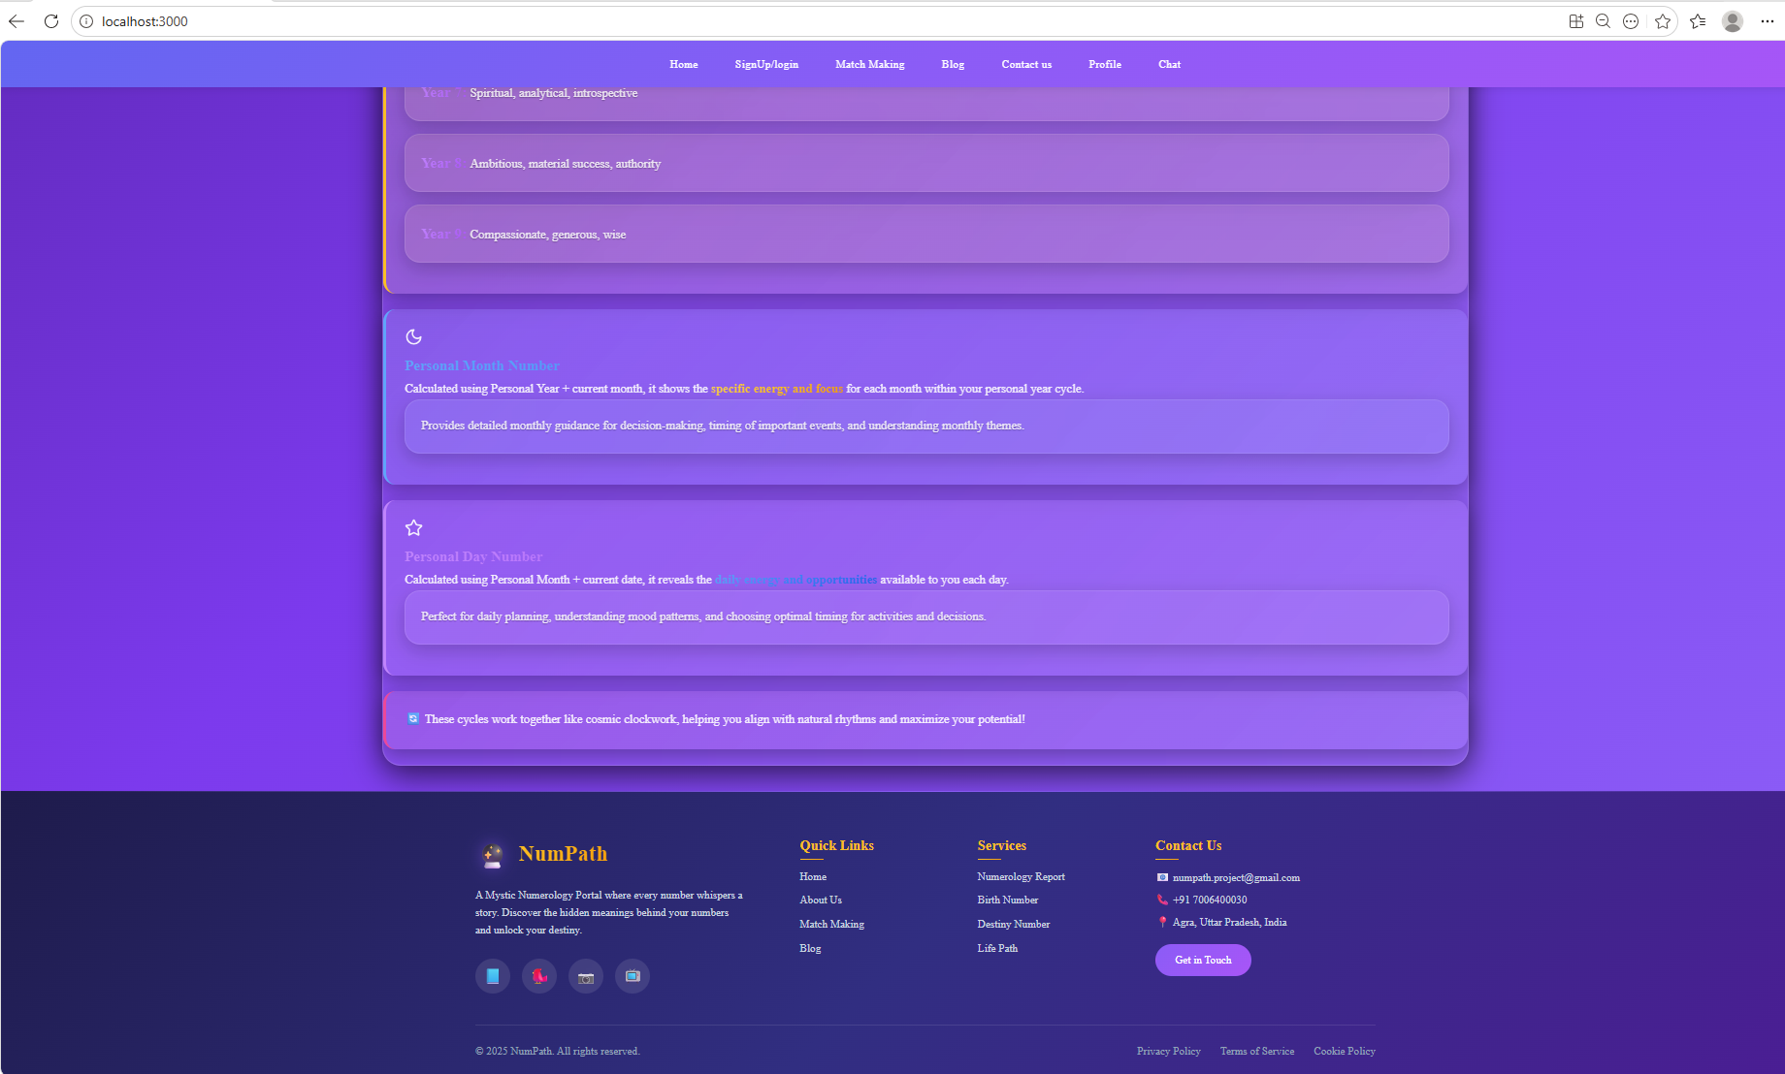

14.2 Login Page

The login page provides a secure interface for user authentication, with fields for email and password.

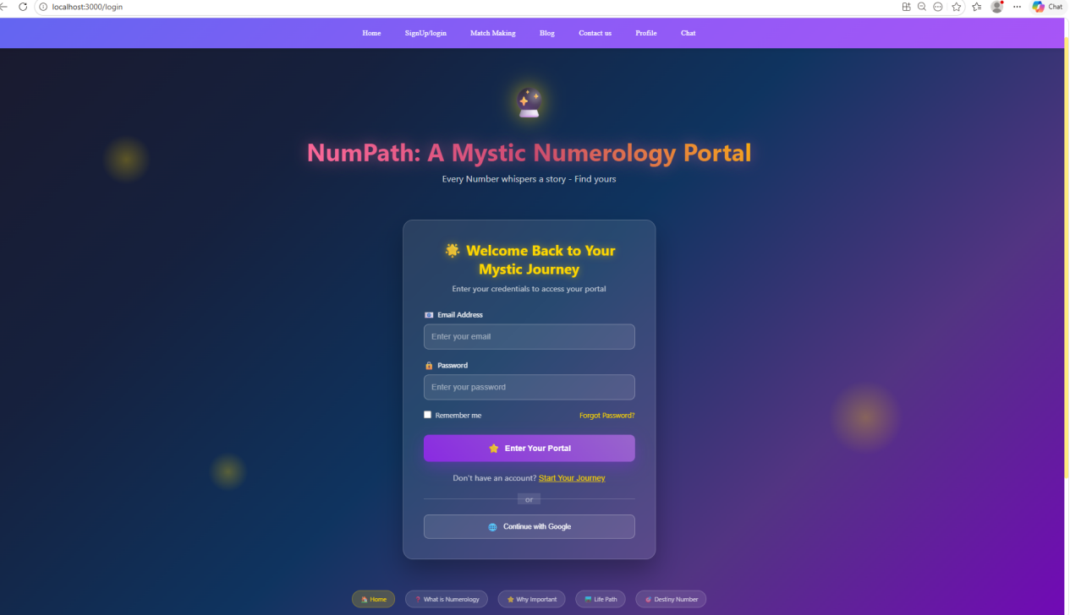

14.3 Compatibility Module
The compatibility module allows users to input two dates of birth and see their calculated compatibility score and analysis.

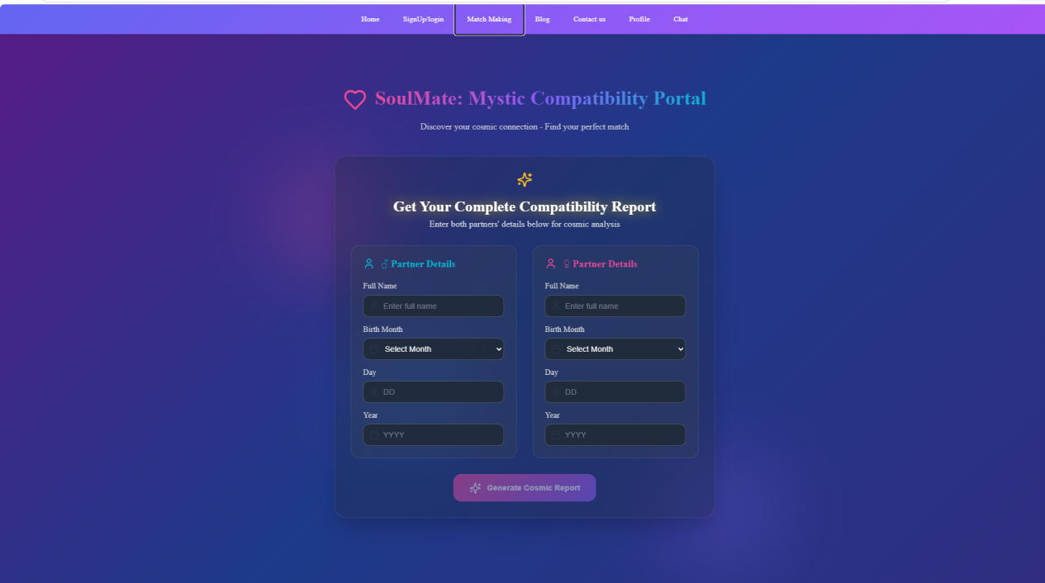

14.4 Blog System
The Blog System in the NumPath application is designed to provide users with informative and engaging content related to numerology concepts, interpretations, and real-life applications. It serves as a knowledge hub that enhances user understanding beyond automated reports.
The blog interface presents a well-structured list of articles with a clean and readable layout, ensuring a smooth reading experience across devices. A featured article section is highlighted at the top to showcase important or trending content, drawing user attention to key insights.
To improve usability, the system includes category-based filtering and a search functionality, allowing users to easily navigate through topics such as life path numbers, master numbers, relationships, and personal cycles. Each article is displayed with essential metadata, including title, category, and brief description, enabling quick content discovery.
The overall design focuses on readability, intuitive navigation, and content accessibility, making the blog system an effective tool for both learning and exploration within the platform.

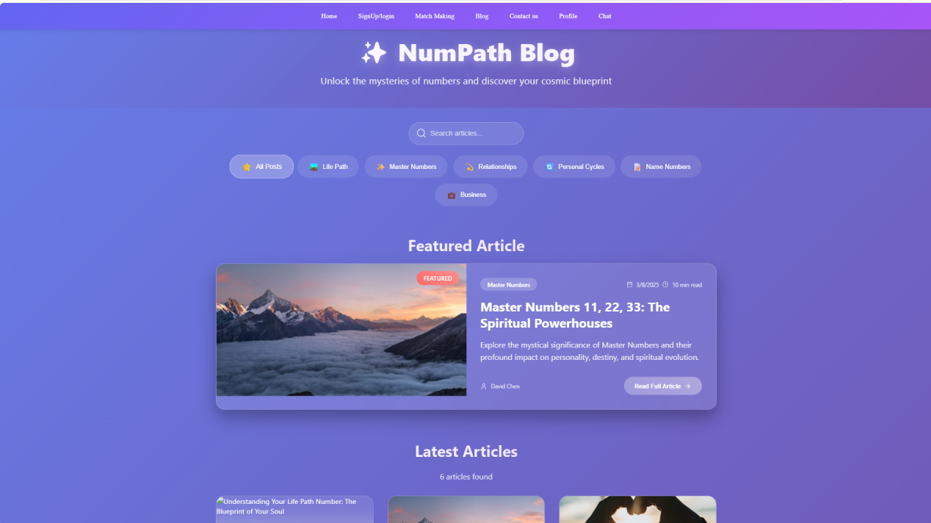

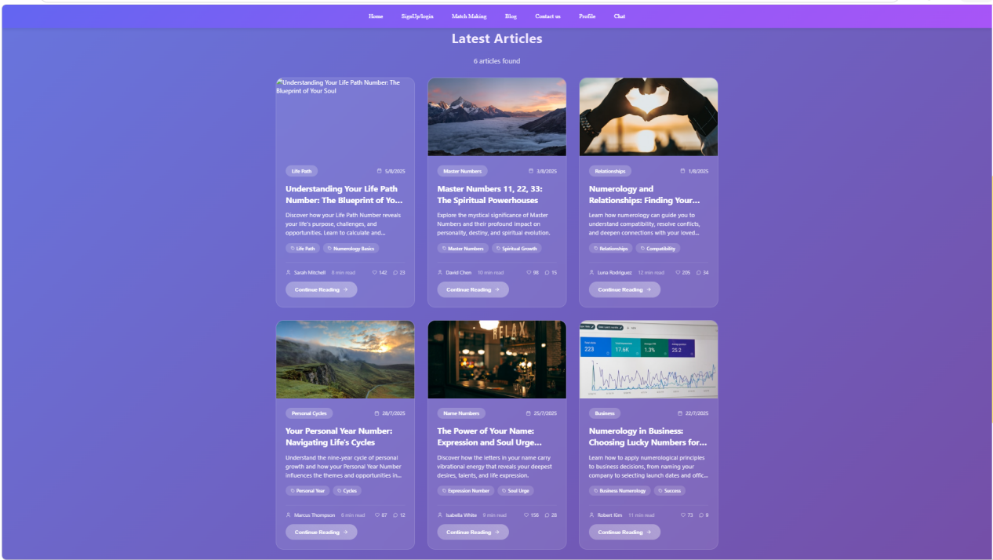

14.5 AI Chatbot Interface
The chatbot interface is a full-page conversational UI, designed to mimic popular chat applications, with message bubbles and an input field.

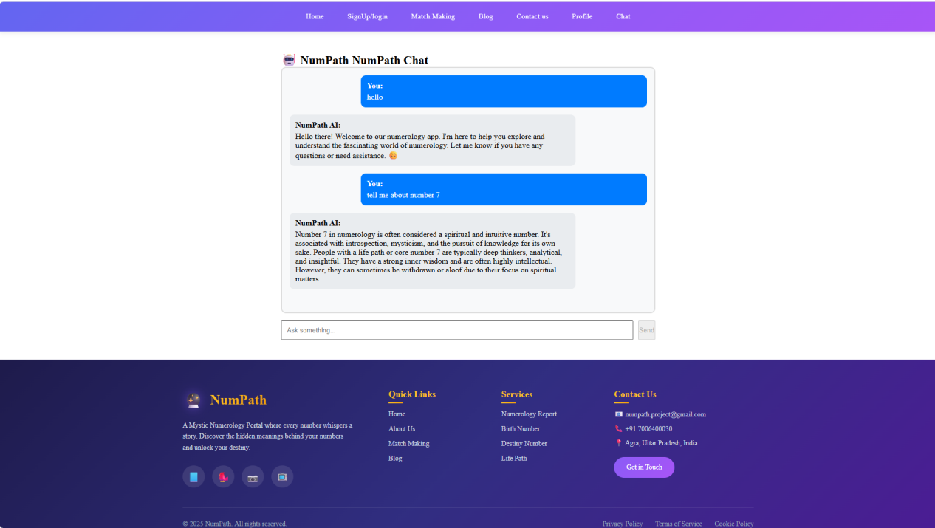

15. Maintenance

15.1 Maintenance Plan
Post-deployment, the NumPath system requires continuous maintenance to ensure long-term reliability, security, and optimal performance. The maintenance strategy includes the following components:
- Security Updates and Dependency Management
Regular updates of core technologies including Node.js, React, and PostgreSQL, along with third-party libraries, to address security vulnerabilities and maintain system integrity.
- Automated Database Backup and Recovery
Implementation of scheduled automated backups for the PostgreSQL database to ensure data protection and enable quick recovery in case of system failure or data loss.
- Content Management and Updates
Continuous addition and updating of blog content to maintain relevance, improve user engagement, and enhance SEO performance.
- Performance Monitoring and Process Management
Utilization of process managers such as PM2 to monitor server health, manage application processes, and ensure high availability with minimal downtime.

15.2 Challenges Encountered
During the development of the NumPath system, several technical challenges were identified and addressed:
- Ollama Integration Challenges
Establishing stable communication between the Node.js backend and the locally hosted Ollama server required robust error handling, proper API request management, and timeout optimization to handle latency and ensure consistent AI responses.
- Database Schema Management
Frequent changes in database structure during development necessitated the use of migration strategies to maintain data consistency and avoid conflicts across different versions of the application.
- Frontend State Synchronization
Maintaining synchronization between the React frontend and backend data required efficient state management using React Context API and hooks, ensuring real-time updates and a seamless user experience.

- Future Scope
The future development of the NumPath platform will focus on enhancing both technological capabilities and user-specific experiences across diverse target segments:
- Personalized Insights for Individuals
Enhance AI-driven personalization to provide users with accurate life guidance, better decision-making support, and improved self-awareness.
- Professional Tools for Coaches & Counselors
Develop dedicated dashboards and client-analysis tools to help professionals integrate numerology into their coaching and wellness practices.
- Community Features for Spiritual Users
Introduce user profiles, discussion forums, and shared insight platforms to increase engagement among spiritual and numerology enthusiasts.
- Organizational Use for HR Professionals
Expand features to support team compatibility analysis, personality mapping, and workplace alignment for organizational environments.
- Mobile Application Development
Build a cross-platform mobile application to improve accessibility and ensure seamless user experience on Android and iOS devices.
- Premium Subscription Services
Introduce paid plans offering advanced AI reports, personalized predictions, and chatbot-based guidance.
- API and Platform Integration
Expand the white-label API to integrate with wellness platforms, astrology services, and lifestyle applications.
- AI Model Optimization
Improve system accuracy by fine-tuning AI models using domain-specific numerology data for better predictions and insights.

17. Conclusion

The "NumPath" project successfully demonstrates the effective integration of rule-based numerology techniques with modern AI capabilities within a web-based platform. The system combines traditional numerological calculations with an intelligent AI chatbot to deliver a more interactive and personalized user experience.
All core modules—Numerology Calculator, Compatibility Matchmaking, Blog System, User Authentication, and AI Chatbot—have been successfully designed, implemented, and tested. The platform ensures smooth functionality, user-friendly interaction, and reliable performance across different use cases.
The project not only achieves its primary objective of providing meaningful numerology-based insights but also highlights the potential of combining AI with traditional domains to enhance user engagement and decision-making support.
Furthermore, this project has provided practical exposure to front-end development, system design, and AI integration, making it a valuable learning experience. It also establishes a scalable foundation for future enhancements, including advanced personalization, mobile accessibility, and extended user-focused features.

18. References
The following references were used during the development of the NumPath project:

Web Technologies & Frameworks
- Official documentation of React
https://reactjs.org/docs
- Official documentation of Node.js
https://nodejs.org/docs
- Official documentation of Express.js
https://expressjs.com/
- Learning resources from MDN Web Docs
https://developer.mozilla.org/

Database
- Official documentation of PostgreSQL
https://www.postgresql.org/docs/

AI & Chatbot
- Official documentation of Ollama
https://ollama.ai/

Development Tools
- Source code editor: Visual Studio Code
https://code.visualstudio.com/
- Web browser used for testing: Google Chrome
https://www.google.com/chrome/
- Version control platform: GitHub
https://github.com/

Domain Knowledge
- Various books and online materials related to numerology concepts
- Standard academic project report formats and reference samples

